Self- Assessment Report (SAR)

Revised 5 Questionnaires

(posted on our website)

Self- Assessment (SA) is the assessment of the QA criteria and standards by analyzing…

Survey Data

Other Evidences

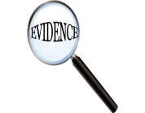

Supported By Supported By

List of Evidences (rough guideline) + EPR Checklist

(posted on our website + handout today)

 Review

1 Year

Improvement Plan

4 Years